LAB 01:

25K-0652
Syeda Hira Batool

Task04:
#include <iostream>
#include <cstring>
using namespace std;

class Exam {

private:
char* studentName;

/* the char pointer is the part of our Exam object, it points to studentName character array
which is dynamically located in the heap

*char ---> [][][][][]

*/

public:

Exam(const char* name){ //this is a parameterized constructor
studentName = new char[strlen(name) + 1]; //allocate memory on the heap
strcpy(studentName, name); //cstring function: copy the name into the heap
cout<<"Memory Allocated for: " << studentName << endl;
}

void display(){
cout << "Student Name: " << studentName << endl;
}

~Exam(){ //this is the destructor: runs in reverse order as constructor
cout << "Memory Released for: " << studentName << endl;
delete[] studentName; //this releases the memory
}
};

int main() {

/*each object is stored on the STACK, but each object's studentName points to a DIFFERENT
dynamically allocated character array on the HEAP */

Exam exam1("Syeda");
Exam exam2("Hira");
Exam exam3("Batool");

cout << "\n----------EXAMS----------\n";
cout << "Exam 1: ";
exam1.display();
cout << "Exam 2: ";
exam2.display();
cout << "Exam 3: ";
exam3.display();
cout << "--------------------------\n";

/*
stack visual:

exam1 ---------> [H][i][r][a][\0]

*/

return 0;

}
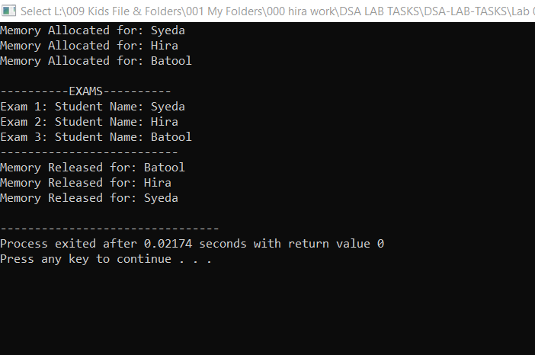

Task05:

